# Downloading AFNI

Depending on your computer’s operating system, you have several different options for downloading and installing the AFNI package. If you do not have any of the required packages, such as R or Homebrew, the entire installation can take 1-2 hours.

Long AFNI direction Version:

# Step 1: Install the Windows Subsystem for Linux

Before installing any Linux distributions on Windows, you must enable the "Windows Subsystem for Linux" optional feature.

1.       In the search terminal of your windows computer, enter “Powershell”

2.       Right click power shell

3.       Select run as administrator

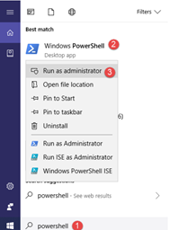

4.       Copy as paste the following command into the terminal

dism.exe /online /enable-feature /featurename:Microsoft-Windows-Subsystem-Linux /all /norestart

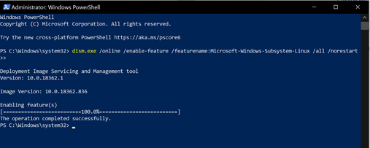

# Step 2: Install your Linux distribution of choice & VcXsrv Windows X Server

I personally use Ubantu, use the following link to download Ubantu

<https://www.microsoft.com/en-us/p/ubuntu-2004-lts/9n6svws3rx71?rtc=1&activetab=pivot:overviewtab>

1.       From the distribution page select “Get”

2.       The first time you launch a newly installed Linux distribution, a console window will open and you'll be asked to wait for a minute or two for files to de-compress and be stored on your PC. All future launches should take less than a second.

3.       You will then need to create a user account and password for your new Linux distribution.

# Install VcXsrv Windows X Server

Copy & paste the link start automatic download (this will be on your desktop not Ubanut):

https://sourceforge.net/projects/vcxsrv/files/latest/download

Use default installation settings.

Now and forever, first doubleclick on the VcXsrv icon on your Desktop, and then start Ubuntu, for example by typing “ubuntu” in the Windows search bar. (Sorry, not our design!)

Short Version (Recommended)   
The AFNI directions can be hard to follow. This simplifies the process for the end-user, who may not be a Windows or Linux expert. I suggest following this format.

# Clone Repo

git clone <https://github.com/aaroneg/Install-AFNI-on-Ubuntu-on-Windows>

cd Install-AFNI-on-Ubantu-on-Windows

# Install Afni Environment

Copy & Paste

sh ./initializeEnvironment.sh

* Close your Ubuntu window and re-open
* cd into the repo

cd Install-AFNI-on-Ubantu-on-Windows

# Install R

sh ./installR.sh

# Make AFNI profiles, prepare for bootcamp and evaluate system:

sh ./createAfniProfiles.sh

# Run Afni

Every time you run afni you need to be running your X server first.

Launch Ubuntu

afni

The directions below are based on AFNI documentation. This is long version of the installation process.

# Install Afni (the long tedious way)

(not necessary if you were able to download the short way)

1. Copy+paste:

sudo add-apt-repository universe

2. Copy+paste:

sudo apt-get update

sudo apt-get install -y tcsh xfonts-base python-qt4   \

                     python-matplotlib             \

                     gsl-bin netpbm gnome-tweak-tool   \

                     libjpeg62 xvfb xterm vim curl \

                     gedit evince eog              \

                     libglu1-mesa-dev libglw1-mesa \

                     libxm4 build-essential        \

                     libcurl4-openssl-dev libxml2-dev  \

                     libssl-dev libgfortran3       \

                     gnome-terminal nautilus       \

                     gnome-icon-theme-symbolic     \

                     firefox xfonts-100dpi

Purpose: Installs a lot of packages that AFNI depends on (so we don’t have to reinvent the wheel!). This may take a little while to complete running.

Some of these packages also improve terminal behavior, especially if you are running Ubuntu on a Windows machine

-          You may receive an error for python-qt-4, it is no longer necessary for afn so no worries.

3. Copy+paste:

  sudo ln -s /usr/lib/x86_64-linux-gnu/libgsl.so.23 /usr/lib/x86_64-linux- gnu/libgsl.so.19

Purpose: Make a symbolic link for the specific version of GSL included in this version of Ubuntu.

# Install AFNI binaries

1.       Copy & paste:

cd

curl -O https://afni.nimh.nih.gov/pub/dist/bin/misc/@update.afni.binaries

tcsh @update.afni.binaries -package linux_ubuntu_16_64 -do_extras

Purpose: Download and unpack the current binaries in your $HOME directory; set the AFNI binary directory name to $HOME/abin/; and add that location to the $PATH in both ~/.cshrc and ~/.bashrc.

2.       Copy & paste:

cp $HOME/abin/AFNI.afnirc $HOME/.afnirc

suma -update_env

# Install R

Note: again, To check your shell type, copy+paste: echo $0 (If you are on Ubantu WSL you are likely using bash)

1.       For tcsh terminal, copy & paste

setenv R_LIBS $HOME/R

mkdir  $R_LIBS

echo  'export R_LIBS=$HOME/R' >> ~/.bashrc

echo  'setenv R_LIBS ~/R' >> ~/.cshrc

curl -O https://afni.nimh.nih.gov/pub/dist/src/scripts_src/@add_rcran_ubuntu_18.04.tcsh

2.       For bash copy & paste

export R_LIBS=$HOME/R

mkdir  $R_LIBS

echo  'setenv R_LIBS ~/R' >> ~/.cshrc

echo  'export R_LIBS=$HOME/R' >> ~/.bashrc

curl -O https://afni.nimh.nih.gov/pub/dist/src/scripts_src/@add_rcran_ubuntu_18.04.tcsh

Purpose: Step 1 of setting up modern R from scratch. Set the environment variable $R_LIBS to specify where to install+find the packages. The file obtained using curl contains instructions to add a more uptodate set of R libraries to the source list.

2.  Copy & Paste

sudo tcsh @add_rcran_ubuntu_18.04.tcsh

3.  Copy & Paste

rPkgsInstall -pkgs ALL

4. If you are using Windows Subsystem Linux (WSL), and/or if your ‘brms’ package fails to install (as checked in the “Evaluation” step below), then consider to copy+paste

sudo add-apt-repository -y "ppa:marutter/rrutter3.5"

sudo add-apt-repository -y "ppa:marutter/c2d4u3.5"

sudo apt update

sudo apt install -y r-cran-rstan r-cran-shinystan r-cran-brms

# Set up Python

AFNI has *very* minimal Python requirements—at present, matplotlib and numpy—and even these are used in only a couple places (though, for the [recommended automatic QC output from afni_proc.py](https://afni.nimh.nih.gov/pub/dist/doc/htmldoc/tutorials/apqc_html/main_toc.html#tut-apqc-help), matplotlib is necessary).

1.       Copy & paste

wget [https://docs.conda.io/en/latest/miniconda.html#linux-installers](https://docs.conda.io/en/latest/miniconda.html" \l "linux-installers)

bash Miniconda3-latest-Linux-x86_64.sh

2.       Make updates to terminal

Copy & Paste

-For bash:

source ~/.bashrc

-for tcsh:

source ~/.cshrc

You should see a string “(base)” string stuck before your terminal prompt now. Typing **conda -V** should also show you your version number.

Note: If you are receiving an error when you enter conda -V, ensure that you are in bash by simply typing bash.

# Evaluate System Set up

1.       Copy & Paste

afni_system_check.py -check_all

If there are no suggestions, then rejoice!

2.       Open up the AFNI and SUMA GUIs, juuuust to make sure all is well:

afni

suma

# Access & Download HCP Data

1.       Create a free account to access the HCP database -<https://db.humanconnectome.org/>

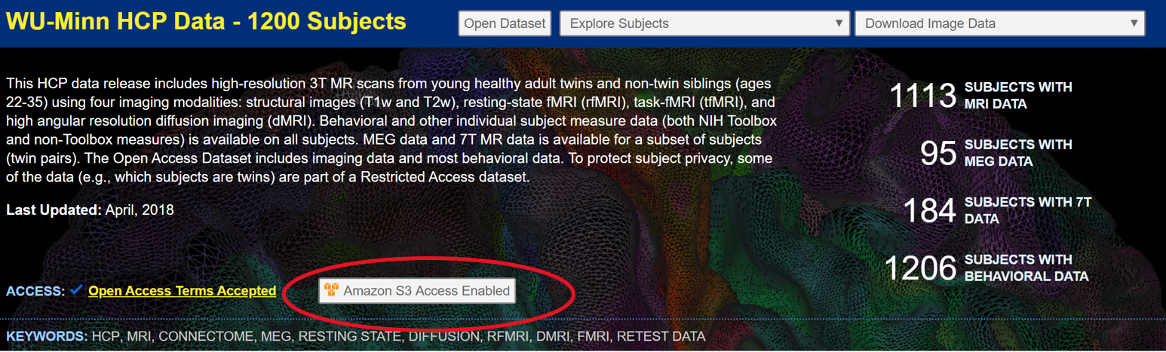

Select the Amazon S3 access enabled option and create Amazon S3 credentials (**save this information for later!**)

2. Download data

-Download the S3 browser at<https://s3browser.com/>

- Select Accounts in top left corner -> new account -> enter your S3 credentials from previous step

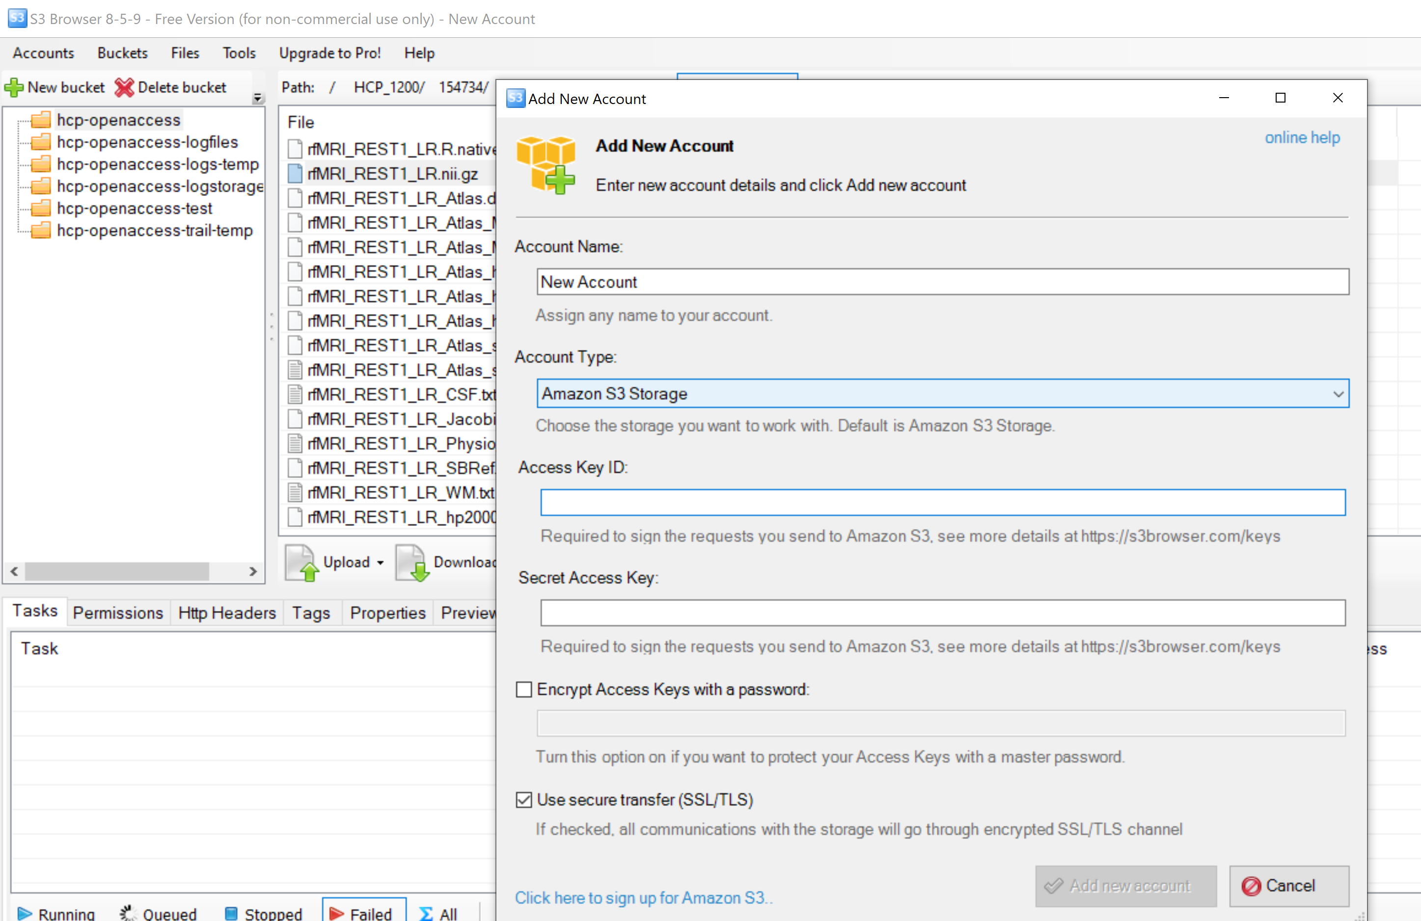

# The data can be found in the following location

# HCP_1200/subjnum/MNINonLinear/Results/rfmri_REST1_LR/

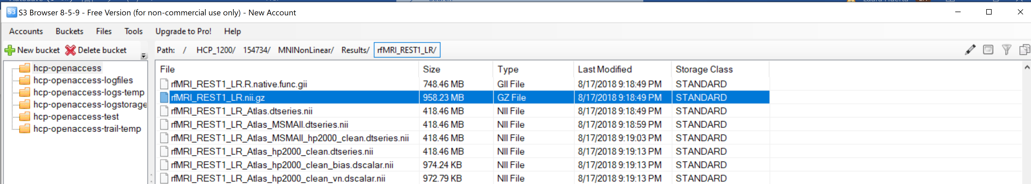

# Steps to loading the bold signal

## Save the fmri file in an afni format

1. Make sure fMRI file is in the underlay.

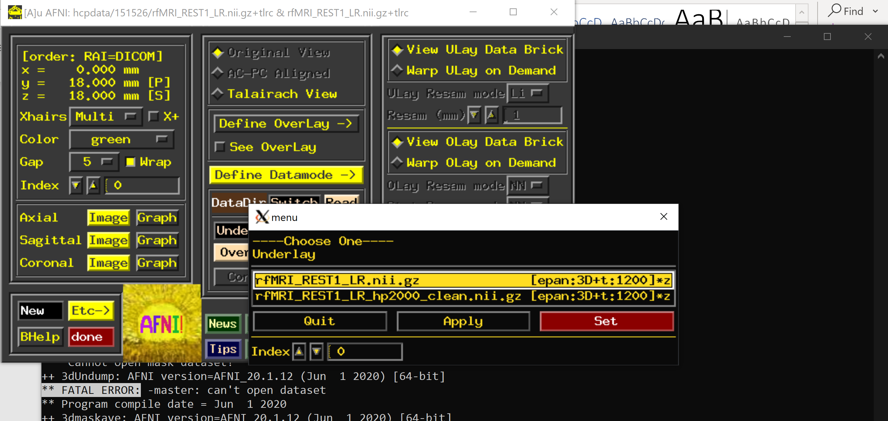



1. Click on the SaveAS on the define datamode column (under resamp and above rescan).

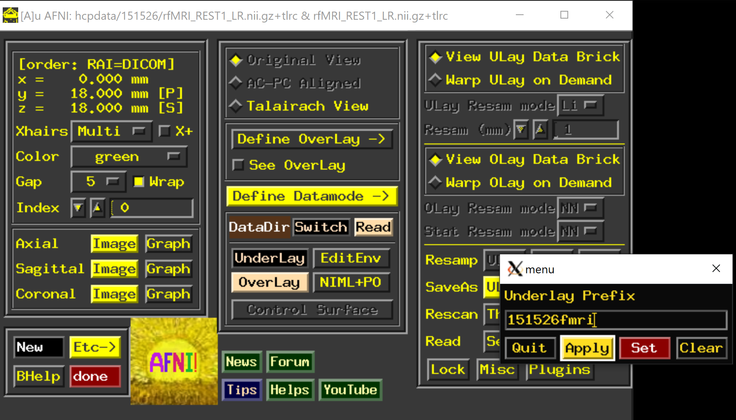



1. Choose a name (such as 151526fmri) note that afni will add +tlrc to the end of your file name

In AFNI, a +tlrc extension (and the “Talairach View”) simply means that the image has been normalized.

4. Hit apply and set (It should now be visable as an underlay

# Extract the bold signal

1. Go into the Terminal

2. put the following command: echo "x y z" | 3dUndump -orient LPI -srad 6 -master fmri+tlrc -prefix hemisphereregionparticipantnumber -xyz –

Where - 3dUndump -prefix (OutputDataset) -master (MasterDataset) -srad (Radius of Sphere, in mm) -xyz (X, Y, and Z coordinates of sphere)

3. type in the following program in the terminal 3dmaskave -mask (hemisphereregionparticipantnumber) (fmri+tlrc)

4. The bold signal will be extracted to a terminal window.

9576.67 (3546 voxels)

9593.81 (3546voxels)

etc....

5. Copy and paste it to an excel file with the participants number and region labled.

## Files

rfmri_rest1_lr.nii.

rfmri_rest1_lr_hp2000_clean.nii.gz

T1w.nii.gz or T2wnii.gz

**Right PCC**

echo "8 -56 26"|3dUndump -orient LPI -srad 6 -master parnumber+tlrc -prefix RPCC -xyz –

3dmaskave -quiet -mask RPCC+tlrc parnumber+tlrc

**Left PCC**

echo "-8 -56 26" | 3dUndump -orient LPI -srad 6 -master parnumber+orig -prefix LPCCparticipantnumber -xyz –

3dmaskave -quiet -mask LPCC+tlrc parnumber+tlrc

**Right MPFC**

echo "6 52 -2" | 3dUndump -orient LPI -srad 6 -master parnumber+tlrc -prefix RMPFC -xyz -

3dmaskave -quiet -mask RMPFC+tlrc parnumber+tlrc

**LEFT MPFC**

echo "-6 52 -2" | 3dUndump -orient LPI -srad 6 -master parnumber+tlrc -prefix LMPFC -xyz –

3dmaskave -quiet -mask LMPFC+tlrc parnumber+tlrc

R DLPFC

echo "43 21 38" | 3dUndump -orient LPI -srad 6 -master 751348+tlrc -prefix RDLPFC -xyz –

3dmaskave -quiet -mask RDLPFC parnumber+tlrc

LDLPFC

echo "-43 21 38" | 3dUndump -orient LPI -srad 6 -master 130013+tlrc -prefix LDLPFC -xyz –

3dmaskave -quiet -mask LDLPFC+tlrc parnumber+tlrc

R. Cohen, Jessica; L. Gallen, Courtney; G. Jacobs, Emily; G. Lee, Taraz; D'Esposito, Mark (2015): Anatomical region (left) and MNI coordinates in mm (right) of the center of each of the intrinsic network ROIs.. PLOS ONE. Dataset. <https://doi.org/10.1371/journal.pone.0106636.t001>

PCC/ MPFC

Andrews-Hanna, J. R., Reidler, J. S., Sepulcre, J., Poulin, R., and Buckner, R. L. (2010). Functional-anatomic fractionation of the brain’s default network. *Neuron* 65, 550–562. doi: 10.1016/j.neuron.2010.02.005

## To automate the process run the following script then copy and paste the output into the excel file.

## Edit the script by changing the participant number 178950 to your own.

#!/bin/bash

#This bash script automates the bold signal extraction.

#type xa to save

#return home and run script with ./scriptname

#master – name of fmri/underlayfile – afni adds +tlrc to end

#prefix- output file

#RPCC

echo "8 -56 26" | 3dUndump -orient LPI -srad 6 -master 178950fmri+tlrc -prefix RPCC178950 -xyz -

3dmaskave -quiet -mask RPCC178950+tlrc 178950fmri+tlrc

#LPCC

echo "-8 -56 26" | 3dUndump -orient LPI -srad 6 -master 178950fmri+tlrc -prefix LPCC178950 -xyz -

3dmaskave -quiet -mask LPCC178950+tlrc 178950fmri+tlrc

#RMPFC

echo "6 52 -2" | 3dUndump -orient LPI -srad 6 -master 178950fmri+tlrc -prefix RMPFC178950 -xyz -

3dmaskave -quiet -mask RMPFC178950+tlrc 178950fmri+tlrc

#LDLPFC

echo "-6 52 -2" | 3dUndump -orient LPI -srad 6 -master 163129fmri+tlrc -prefix LMPFC178950 -xyz -

3dmaskave -quiet -mask LMPFC178950+tlrc 178950fmri+tlrc

#RDLPFC

echo "43 21 38" | 3dUndump -orient LPI -srad 6 -master 178950fmri+tlrc -prefix RDLPFC178950 -xyz -

3dmaskave -quiet -mask RDLPFC178950+tlrc 178950fmri+tlrc

#LDLPFC

echo "-43 21 38" | 3dUndump -orient LPI -srad 6 -master 178950fmri+tlrc -prefix LDLPFC178950+tlrc -xyz -

3dmaskave -quiet -mask LDLPFC178950+tlrc 178950fmri+tlrc

## Some notes about linux and bash scripting

* To create a bash script like the one above in your terminal type

**vi yourfilename**

* To edit (or insert) in a bash script simply type i
* When your done enter esc
* If you have copied from your pc to the terminal you must convert to linux. This step if crucial to your script working. Type

**: set ff=unix**

* To save your work type : and enter xa (save and exit)

**: xa**

* To run your script return to your terminal and type

**./yourfilename**

* Code takes about 5-10 minutes to run. While your waiting you can edit your bash file and replace participant numbers with the next subj.

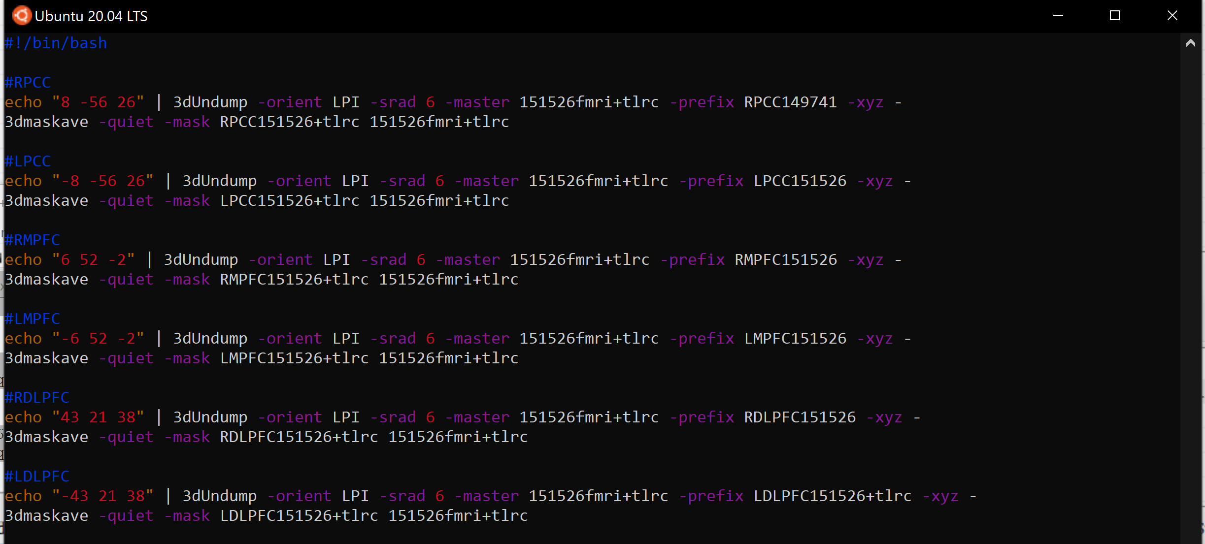

Finally copy and paste each output to the corresponding row in the excel doc

